## REQUIREMENT AND ANALYSIS

**1.1 Organisation Background:**

* **The Aim of Online Booking** provide the easily and excellence whole word option to the customer. Its highly informative, user friendly. It provides the quality services to the various customers. Booking hotel with the agent is time consuming process. In this situation internet provide the best way to book a room in hotel. It discovers the more information about hotel which is situated in particular area and also select hotel according to your demands.

* In this website it provide user friendly consumes minimal time and effort of customerRoom rate can be controlled better and reservation can be increased directly by their own side.

* It is a secure online reservations website
* Maintaining and searching for records would be easier in this system.

* 1. **Problem Definition**

Manual process of keeping customer records account details managing customer is very difficult. There are various problems also faced by the customer such as finding Hotel information whether Rooms is available or not, for what time the Rooms will be available, searching of their preference of restaurant

When you book offline restaurent you get the Disadvantage of comparing different packages, price of hotel etc. You can not choose the best suitable deal for you. Offline booking does not offers discounts thus it will consume your money as well as time.

To eliminate this manual system, Hotel booking system has been developed. It will handle all the current issues faced by the Booker

* 1. **Feasibility Study**

* + 1. **Schedule Feasibility Study:**

|  |  |  |  |  |  |  |
| --- | --- | --- | --- | --- | --- | --- |
|  |  | **Planning** | **Research** | **Design** | **Implementation** | **Follow Up** |
| **August** | 1st week |  |  |  |  |  |
| 2nd week |  |  |  |  |  |
| 3rd week |  |  |  |  |  |
| 4th week |  |  |  |  |  |
| **September** | 1st week |  |  |  |  |  |
| 2nd week |  |  |  |  |  |
| 3rd week |  |  |  |  |  |
| 4th week |  |  |  |  |  |

* + 1. **Technical Feasibility Study:**

❖ HARDWARE AND SOFTWARE REQUIREMENT.

* + - * + Hardware Requirements.

|  |  |
| --- | --- |
| RAM | 8GB ram |
| Device | Monitor |
| Connection | Internet |
| Processor | Intel i5 10th generation |

* + - * + Software Requirements.

|  |  |
| --- | --- |
| Browser | Chrome |
| Editor | Visual Studio |
| OS | Windows |
| Language | Html, CSS,javascript |

## DESIGN

**2.1 Site Map**



MENU



HOME



SERVICES



**Food Service/**

**Food Runner**



KNOW MORE



**Refreshment**



KNOW MORE



**Housekeeping**



KNOW MORE



**Room**

**Security**



KNOW MORE



ROOM



BOOK NOW



Customers



**About Us**

**2.2 Flow chart**



BOOKING PAGE



Please fill dates



Not

S

u

cces

s



Data Saved



Local storage



Booking cancelled



R

emove Booking



IF

**2.3 Activity Diagram**

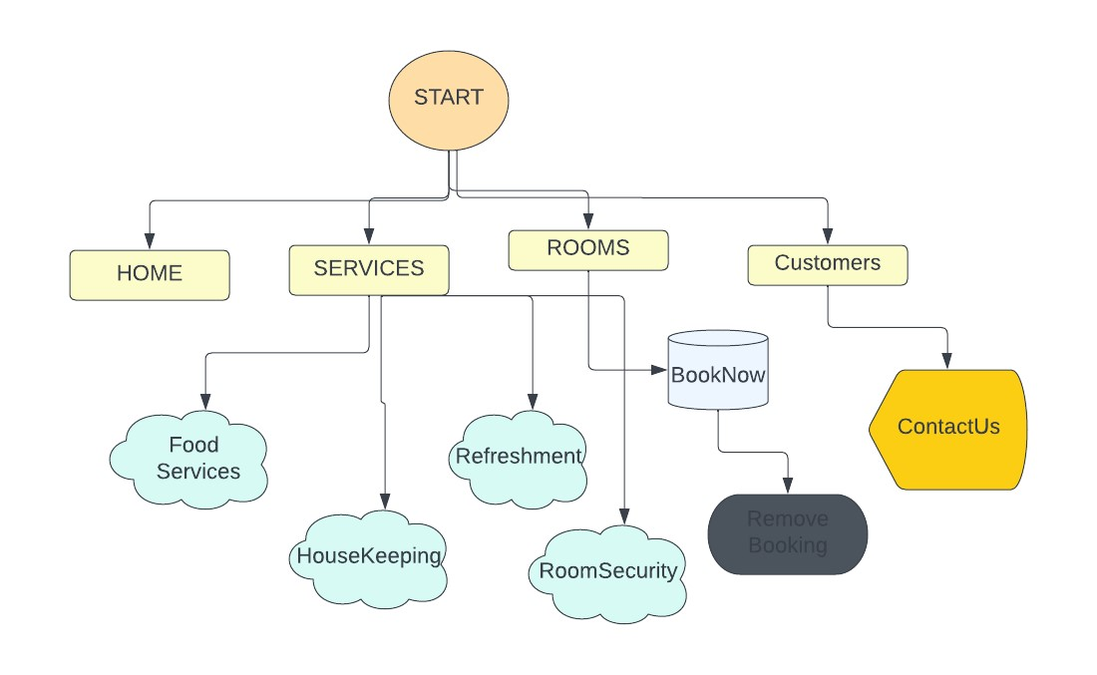

## CODING PHASE

**3. Code :**

**<html>**

**<head>**

**<meta charset="utf-8">**

**<title>Mandarin Oriental </title>**

**<meta name="viewport" content="width=device-width, initial-scale=1">**

**<link rel="stylesheet" href="css/main.css">**

**<!-- javascript-->**

**<script src="https://kit.fontawesome.com/dbed6b6114.js" crossorigin="anonymous"></script>**

**<link rel = "icon" href = "ankit" type = "image/png">**

**<!--end of javascript-->**

**</head>**

**<body>**

**<!-- header -->**

**<header class = "header" id = "header">**

**<div class = "head-top">**

**<div class = "site-name">**

**<span>ANKIT</span>**

**</div>**

**<div class = "site-nav">**

**<span id = "nav-btn">MENU <i class = "fas fabars"></i></span>**

**</div>**

**</div>**

**<div class = "head-bottom flex">**

**<h2>NICE AND COMFORTABLE PLACE TO STAY</h2>**

**<p>The company itself is a very successful company. It is just that those who are pardoned never hinder pleasures, we accuse them of harsher sayings, of choosing, or as they happen, the modes of these annoyances and the smallest duties born.</p>**

**<button type = "button" class = "head-btn">GET**

**STARTED</button>**

**</div>**

**</header>**

**<!-- end of header -->**

**<!-- side navbar -->**

**<div class = "sidenav" id = "sidenav">**

**<span class = "cancel-btn" id = "cancel-btn">**

**<i class = "fas fa-times"></i>**

**</span>**

**<ul class = "navbar">**

**<li><a href = "#header">home</a></li>**

**<li><a href = "#services">services</a></li>**

**<li><a href = "#rooms">rooms</a></li>**

**<li><a href = "#customers">customers</a></li>**

**</ul>**

**</div>**

**<!-- end of side navbar -->**

**<div class = "book">**

**<form class = "book-form" id="form" >**

**<div class = "form-item">**

**<label for = "Your Name">Your Name: </label>**

**<input type = "Your Name" id = "Your Name">**

**</div>**

**<div class = "form-item">**

**<label for = "Your Email">Your Email/Mobile No: </label>**

**<input type = "Your Email" id = "Your Email">**

**</div>**

**<div class = "form-item">**

**<label for = "checkin-date">Check In Date: </label>**

**<input type = "date" id = "chekin-date">**

**</div>**

**<div class = "form-item">**

**<label for = "checkout-date">Check Out Date: </label>**

**<input type = "date" id = "chekout-date">**

**</div>**

**<div class = "form-item">**

**<label for = "adult">Adults: </label>**

**<input type = "number" min = "1" value = "1" id = "adult"> </div>**

**<div class = "form-item">**

**<label for = "children">Children: </label>**

**<input type = "number" min = "1" value = "1" id = "children">**

**</div>**

**<div class = "form-item">**

**<label for = "rooms">Rooms: </label>**

**<input type = "number" min = "1" value = "1" id = "rooms"> </div>**

**<div class = "form-item">**

**<input type = "submit" class = "btn" value = "Book Now" id="submit">**

**</div>**

**</form>**

**</div>**

**<!-- Show Content from localstorage -->**

**<!-- end -->**

**<section class = "rooms sec-width" id = "rooms">**

**<div class = "title">**

**<h2>rooms</h2>**

**</div>**

**<div class = "rooms-container">**

**<!-- single room -->**

**<article class = "room">**

**<div class = "room-image">**

**<img src = "https://www.vayaresorts.com/wpcontent/uploads/2021/06/dsf0246-1.jpg" alt = "room image">**

**</div>**

**<div class = "room-text">**

**<h3>Standard Rooms</h3>**

**<ul>**

**<li>**

**<i class = "fas fa-arrow-alt-circleright"></i>**

**The customer is very happy.**

**</li>**

**<li>**

**<i class = "fas fa-arrow-alt-circleright"></i>**

**The customer is very happy.**

**</li>**

**<li>**

**<i class = "fas fa-arrow-alt-circleright"></i>**

**The customer is very happy.**

**</li>**

**</ul>**

**<p>our most economical, are perfect for guests**

**satisfied with a compact room and window opening onto a light well.Basic rooms**

**are also compact but slightly larger than a budget, with a window that**

**provides a limited view.</p>**

**<p>Standard rooms are more spacious and offer a city**

**view for example. In so far as budget, basic and standard rooms are compact so**

**are the bathroom facilities. The sink is in-room with toilet & shower**

**separately enclosed.</p>**

**<p class = "rate">**

**<span> ₹900 /</span> Per Night**

**</p>**

**</div>**

**</article>**

**<!-- end of single room --<!-- footer -->**

**<footer class = "footer">**

**<div class = "footer-container">**

**<div>**

**<h2>About Us </h2>**

**<p>The company itself is a very successful company. And so**

**they provide a wise resilience to pains? Guilt hinders them from anything or**

**suffering.</p>**

**<ul class = "social-icons">**

**<li class = "flex">**

**<a href="https://www.facebook.com/"><i class = "fa**

**fa-facebook fa-2x"></i></a>**

**</li>**

**<li class = "flex">**

**<a href="https://www.instagram.com/"><i class =**

**"fa fa-instagram fa-2x"></i></a>**

**</li>**

**<li class = "flex">**

**<a href="https://twitter.com/i/flow/login"></a><i**

**class = "fa fa-twitter fa-2x"></i></a>**

**</li>**

**</ul>**

**</div>**

**<div>**

**<h2>Useful Links</h2>**

**<a href = "#">Blog</a>**

**<a href = "#">Rooms</a>**

**<a href = "#">Subscription</a>**

**<a href = "#">Gift Card</a>**

**</div>**

**<div>**

**<h2>Privacy</h2>**

**<a href = "#">Career</a>**

**<a href = "#">About Us</a>**

**<a href = "#">Contact Us</a>**

**<a href = "#">Services</a>**

**</div>**

**<div>**

**<h2>Have A Question</h2>**

**<div class = "contact-item">**

**<span>**

**<i class = "fas fa-map-marker-alt"></i>**

**</span>**

**<span>**

**17**

**203 Vaksai Naka Old Mumbai Pune Highway,Lonavala -**

**410 401**

**</span>**

**</div>**

**<div class = "contact-item">**

**<span>**

**<i class = "fas fa-phone-alt"></i>**

**</span>**

**<span>**

**+918450934492**

**</span>**

**</div>**

**<div class = "contact-item">**

**<span>**

**<i class = "fas fa-envelope"></i>**

**</span>**

**<span>**

**@mandarinorientalhotel groups.com**

**</span>**

**</div>**

**</div>**

**</div>**

**<h3 class="credit"> created by <span> mr. ANKIT SINGH </span> |**

**all rights reserved! </h1>**

**</footer>**

**<!-- end of footer -->**

**<script src="js/script.js"></script>**

**</body>**

**</html>**

**</section>**

## DEPLOYMENT

**4.1 Screen Shots:**

### This is home page of the website. You can check here Service as well as details of hotel and reviews of our past booker

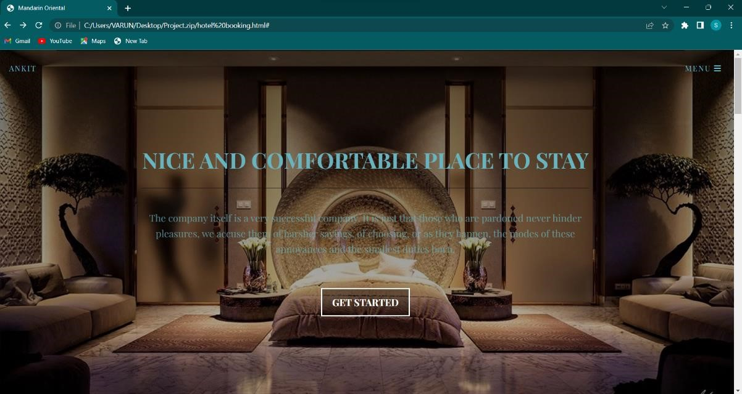

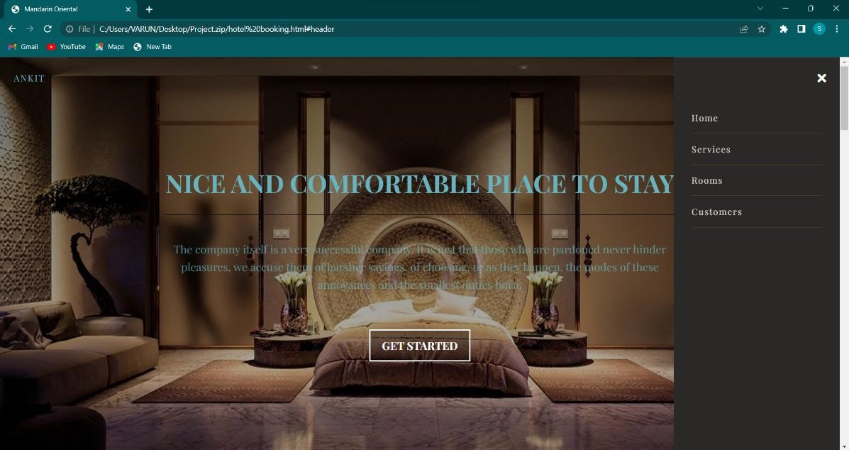

**Click on the service page it will take you to services section**

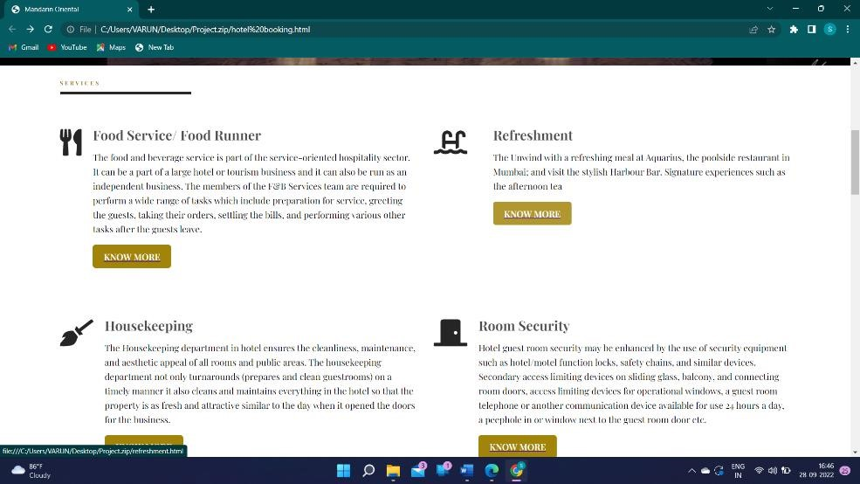

**Click on know more info page it will take you to different services which have been provided**

1. **Food/services**

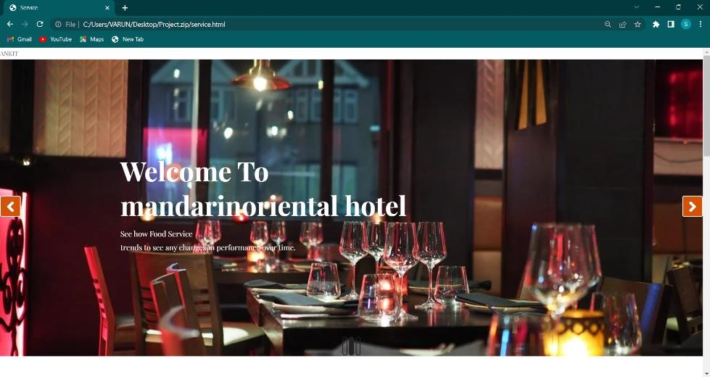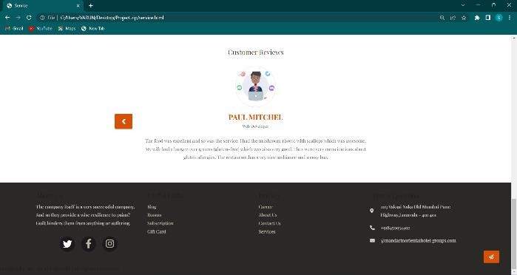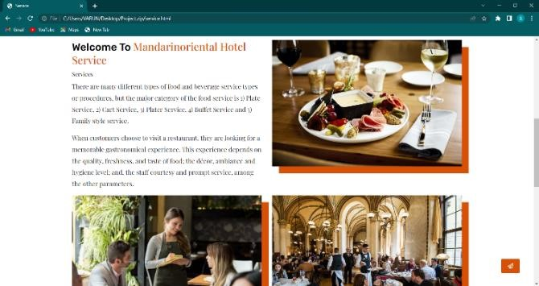

1. **Housekeeping**

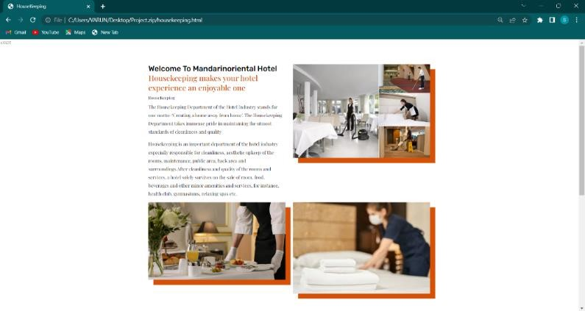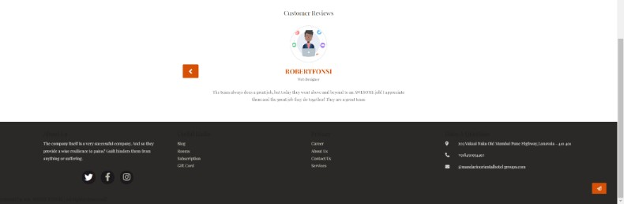

1. **Refreshment**

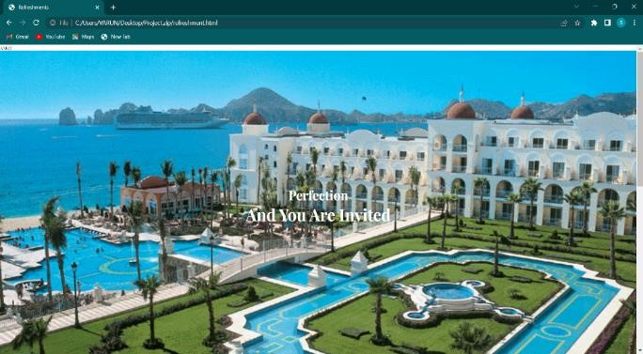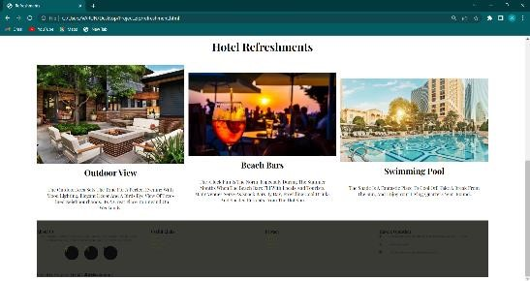

1. **Room security**

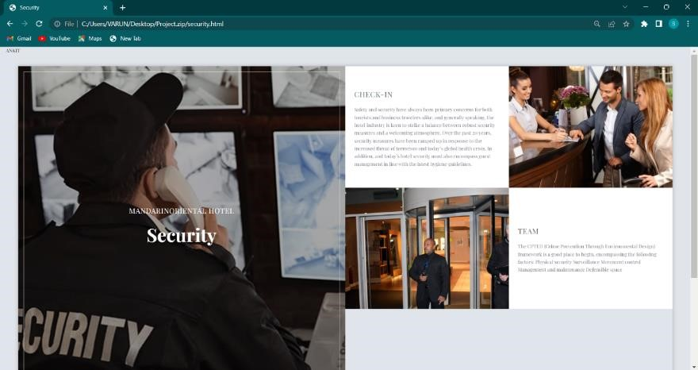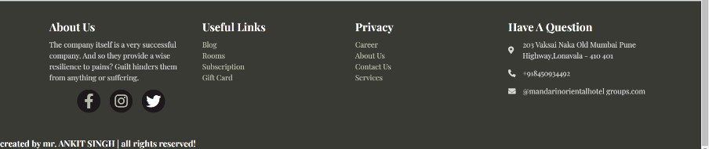

### Click on the Rooms section The book now section will book the Hotel the period of time you want to be

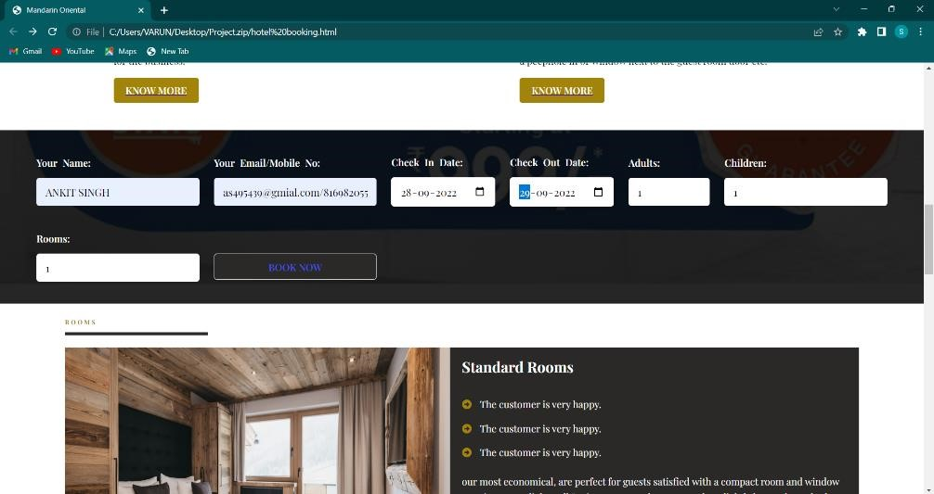

### After clicking on booknow button the data will be saved

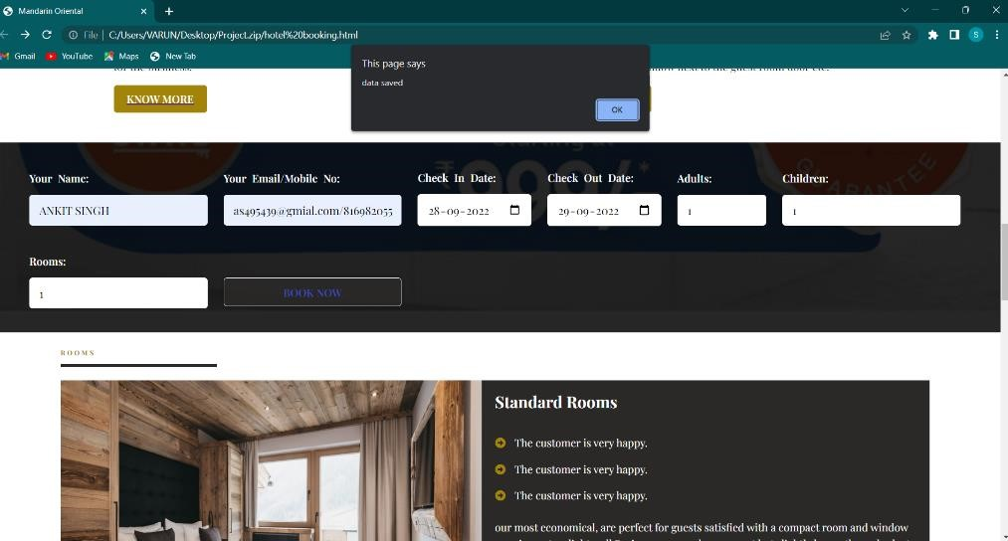

### In this page you can see who has booked the reasturent

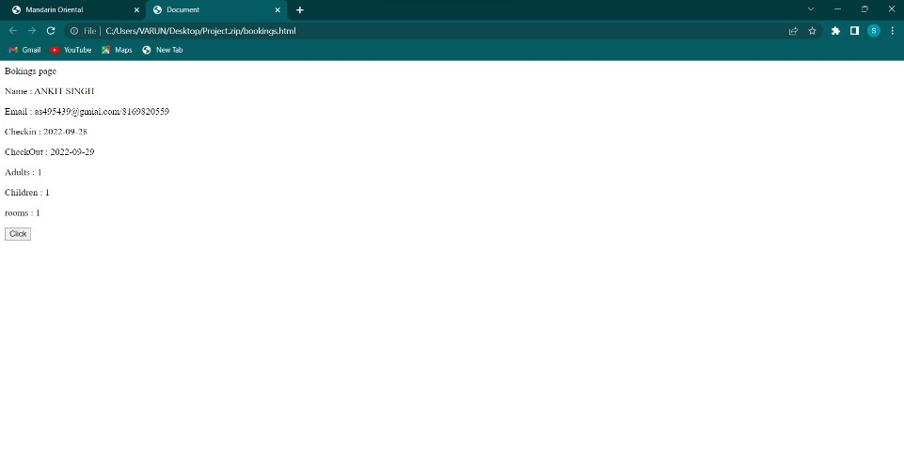

**Click on the coustomers page**

### Here you can see previous reviews of people who have expirinced lifestyle of mandarinorientalhotel

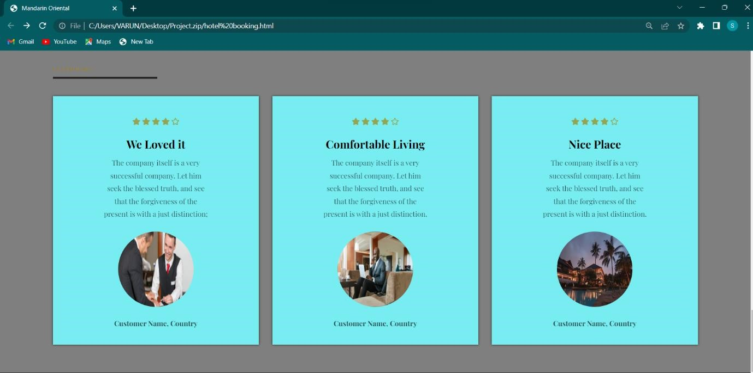

### Contact Us page

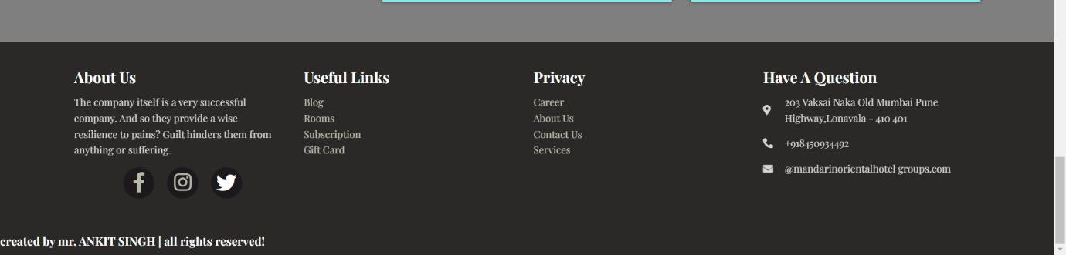

1. **CONCLUSION :**

**Conclusion**

* 1. **While developing this project I have learnt a lot about hotel management.**

* 1. **The Online Hotel Reservation System was developed to replace the manual**
  2. **process of booking for a hotel room or any other facility of the hotel.**

* 1. **The old system does not serve the customer in a better way; rather it makes**
  2. **customer data vulnerable.**

* 1. **The new system keeps proper records of customers for emergency and**
  2. **security purposes.**

* 1. **We have learnt how to make a system user friendly.**

* 1. **We also realized the importance of maintaining a minimal margin for error.**

* 1. **During the development process we studied carefully and understood the criteria of Implementation process.**

**5.1 Future Enhancement:**

* 1. **A customer can book more than one rooms.**

* 1. **Reduce human error and Keep your business running 24/7**

* 1. **Room payment can be done online through secure bank websites**

* 1. **Adavance Online Booking of Hotels for receptions,bussiness meetings,seminar etc cn be provided**

* 1. **Home Services of foods can be provided**

* 1. **Earn value by serving the best to the customer and provide them very smooth luxury and comfort the hotels make their reputaiton and will increase the annual profit and comfort**

**6.Bibliography:**

**SOME VIDEOS REFERRED:**

* 1. [**https://www.youtube.com/watch?v=41q3xQZ_XcM**](https://www.youtube.com/watch?v=41q3xQZ_XcM)
  2. [**https://www.youtube.com/watch?v=ZwxET0Ab_gk**](https://www.youtube.com/watch?v=ZwxET0Ab_gk)

**SOME WEBSITES REFERRED:**

* 1. <https://github.com/search?q=hotel+reservation+html&type=Code>
  2. [https://www.freeprojectz.com/project-source-code-database-download/hotelbooking-system- project](https://www.freeprojectz.com/project-source-code-database-download/hotel-booking-system-%20%20%20%20%20%20%20project)
  3. <https://www.c-sharpcorner.com/>